**LAB EXERCISE 6**

**Aim: Create a simple Maven Project using CLI.**

**Solution:**

First, download Maven and follow the installation instructions. After that, type the following in a terminal or in a command prompt:

**mvn --version**

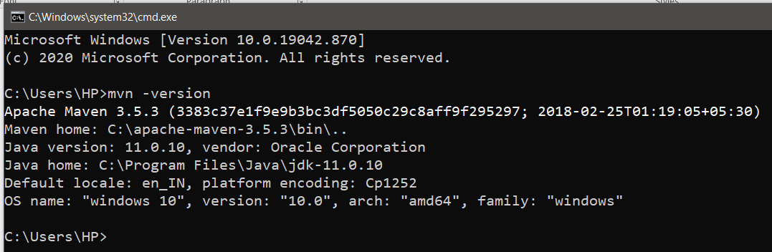

**Creating a Project** **:**

You will need somewhere for your project to reside, create a directory somewhere and start a shell in that directory. On your command line, execute the following Maven goal:

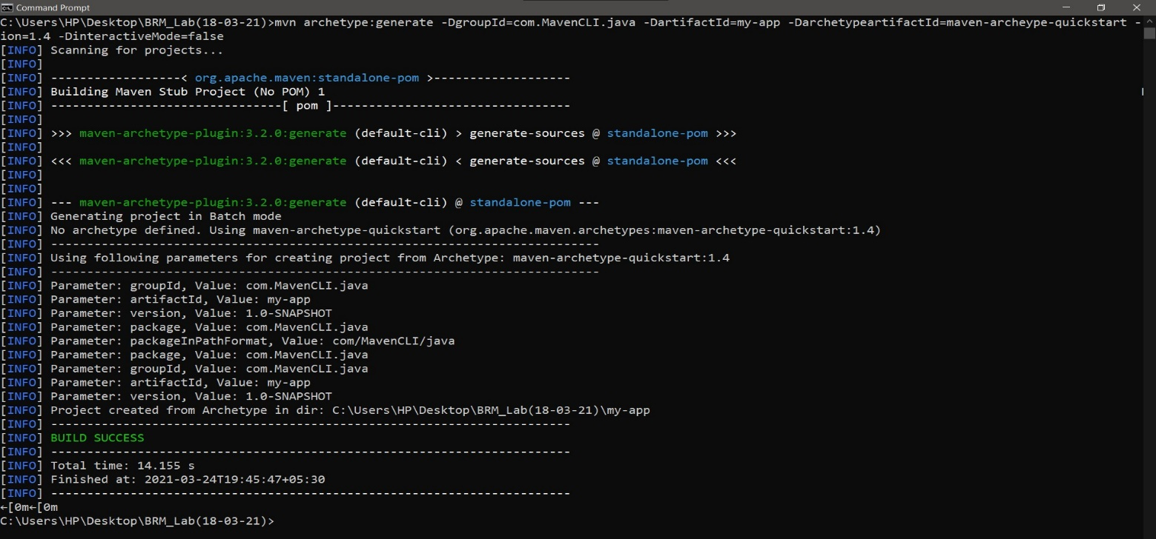

**cd my-app**

Under this directory you will notice the following standard project structure.

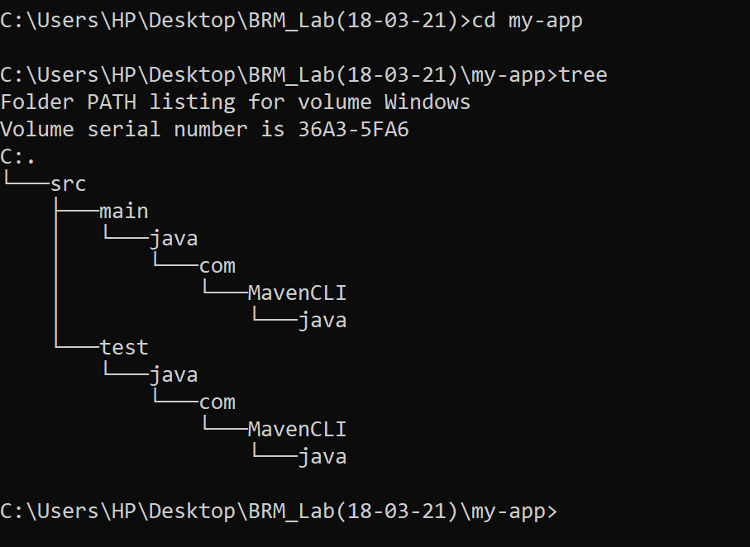

The ***src/main/java*** directory contains the project source code, the ***src/test/java*** directory contains the test source, and the **pom.xml** file is the project's Project Object Model, or POM

**The POM:**

The **pom.xml** file is the core of a project's configuration in Maven. It is a single configuration file that contains the majority of information required to build a project in just the way you want. The POM is huge and can be daunting in its complexity, but it is not necessary to understand all of the intricacies just yet to use it effectively. This project's POM is:

***pom.xml***

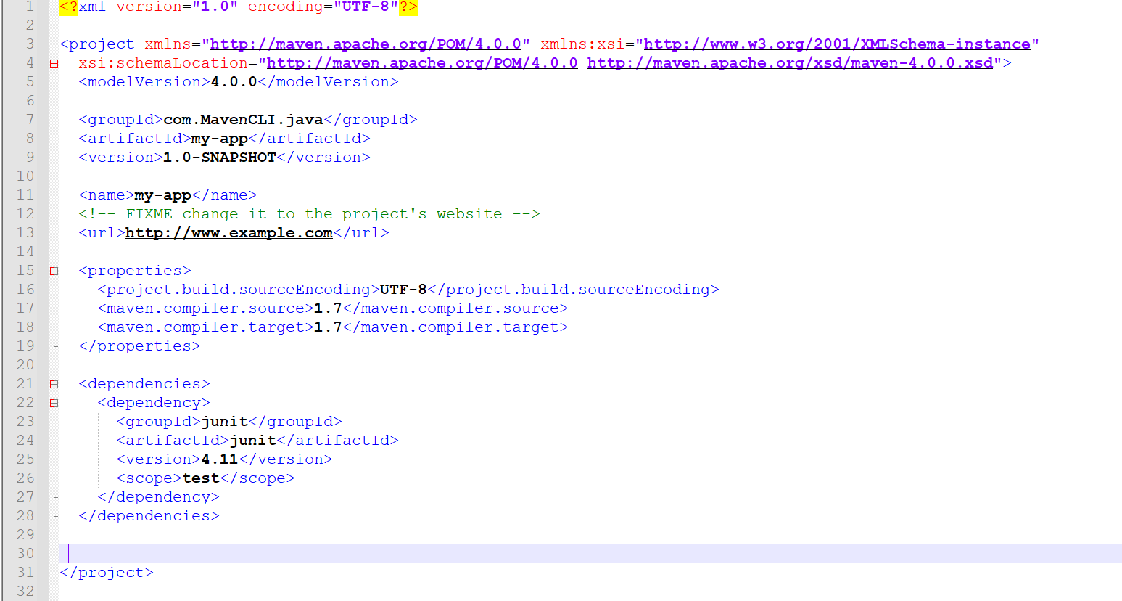

**What did I just do?**

You executed the Maven goal **archetype:generate,** and passed in various parameters to that goal.

The prefix archetype is the plugin that provides the goal. If you are familiar with **Ant**, you may conceive of this as similar to a task. This **archetype:generate** goal created a simple project based upon a **maven-archetype-quickstart** archetype.

Suffice it to say for now that a plugin is a collection of goals with a general common purpose. For example the jboss-maven-plugin, whose purpose is "deal with various jboss items".

**Build the Project 1.**

**mvn package**

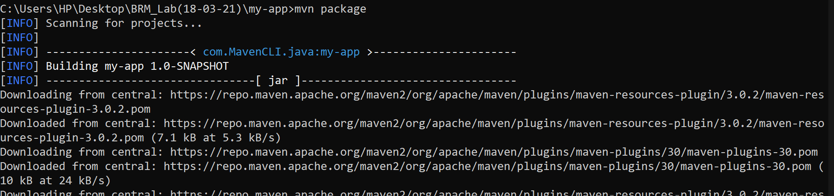The command line will print out various actions, and end with the following:

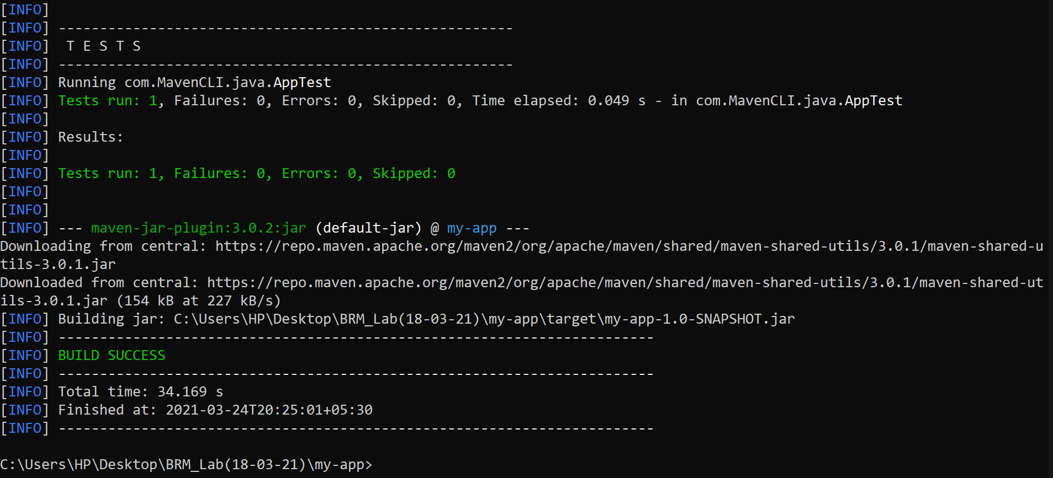

Unlike the first command executed (**archetype:generate**) you may notice the second is simply a single ***word - package***.

Rather than a goal, this is a phase. A phase is a step in the ***build lifecycle***, which is an ordered sequence of phases. When a phase is given, Maven will execute every phase in the sequence up to and including the one defined. For example, if we execute the compile phase, the phases that actually get executed are:

**1. validate**

**2. generate-sources**

**3. process-sources**

**4. generate-resources**

**5. process-resources**

**6. compile**

You may test the newly compiled and packaged JAR with the following command:

1. java -cp target/my-app-1.0-SNAPSHOT.jar com.mycompany.app.App

Which will print the quintessential:

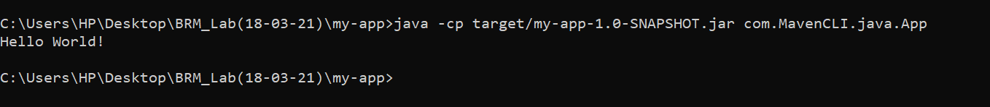

**Maven Phases:**

Although hardly a comprehensive list, these are the most common default lifecycle phases executed.

* **validate**: validate the project is correct and all necessary information is available
* **compile**: compile the source code of the project
* **test**: test the compiled source code using a suitable unit testing framework. These tests should not require the code be packaged or deployed
* **package**: take the compiled code and package it in its distributable format, such as a JAR.
* **integration-test**: process and deploy the package if necessary into an environment where integration tests can be run
* **verify**: run any checks to verify the package is valid and meets quality criteria
* **install**: install the package into the local repository, for use as a dependency in other projects locally
* **deploy:** done in an integration or release environment, copies the final package to the remote repository for sharing with other developers and projects.

There are two other Maven lifecycles of note beyond the default list above. They are

* **clean:** cleans up artifacts created by prior builds
* **site**: generates site documentation for this project

Phases are actually mapped to underlying goals. The specific goals executed per phase is dependant upon the packaging type of the project.

For example, package executes jar:jar if the project type is a JAR, and war:war if the project type is - you guessed it - a WAR.

An interesting thing to note is that phases and goals may be executed in sequence.

1. mvn clean dependency:copy-dependencies package

This command will clean the project, copy dependencies, and package the project (executing all phases up to package, of course).

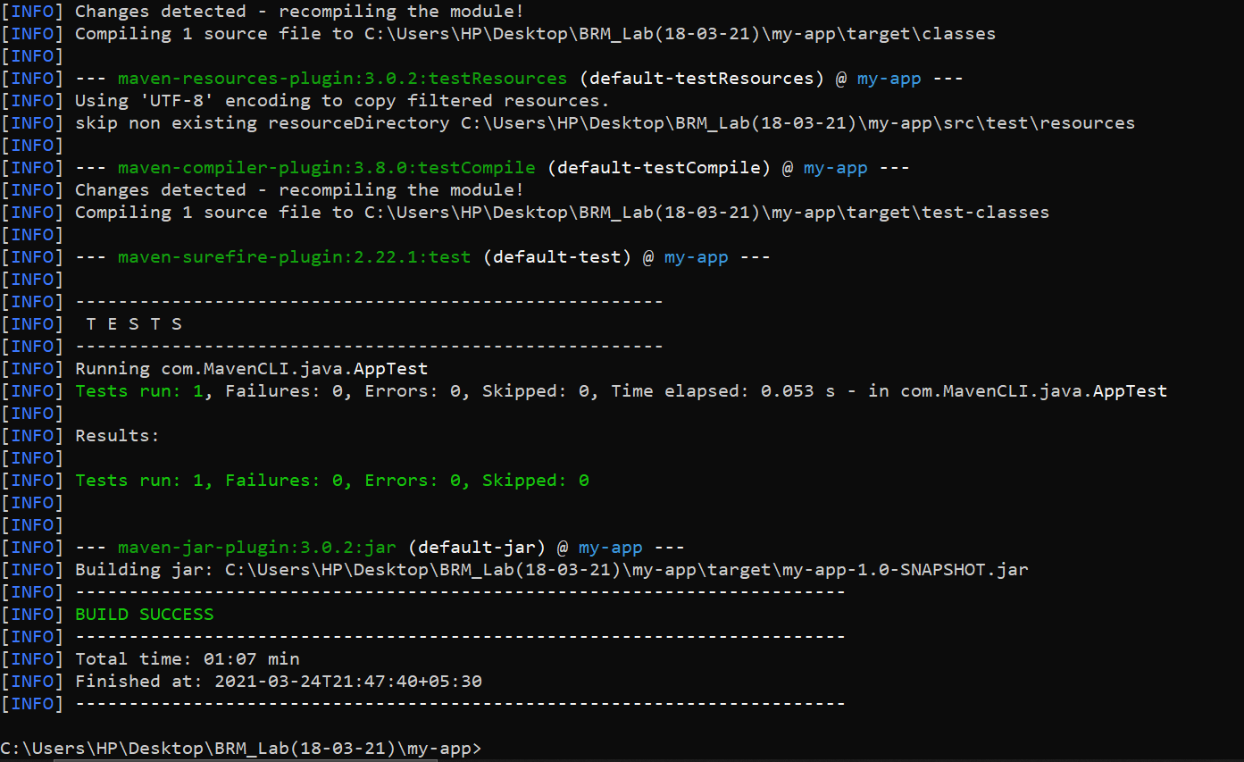

**Generating the Site:**

**mvn site**

This phase generates a site based upon information on the project's pom. You can look at the documentation generated under ***target/site*** .

